# Update a file through a Python algorithm

## 

## Project description

At my organization, access to restricted content is controlled with an allow list of IP addresses. The "allow_list.txt" file identifies these IP addresses. A separate remove list identifies IP addresses that should no longer have access to this content. I created an algorithm to automate updating the "allow_list.txt" file and remove these IP addresses that should no longer have access.

## 

## Open the file that contains the allow list

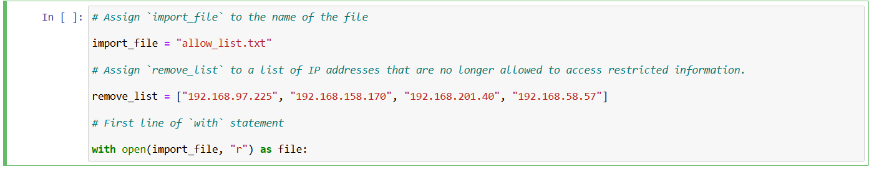

For the first part of the algorithm, I opened the "allow_list.txt" file. First, I assigned this file name as a string to the import_file variable.

Then, I used a with statement to open the file.

In my algorithm, the with statement is used with the .open() function in read mode to open the allow list file for the purpose of reading it. The purpose of opening the file is to allow me to access the IP addresses stored in the allow list file. The with keyword will help manage the resources by closing the file after exiting the with statement.

## 

## Read the file contents

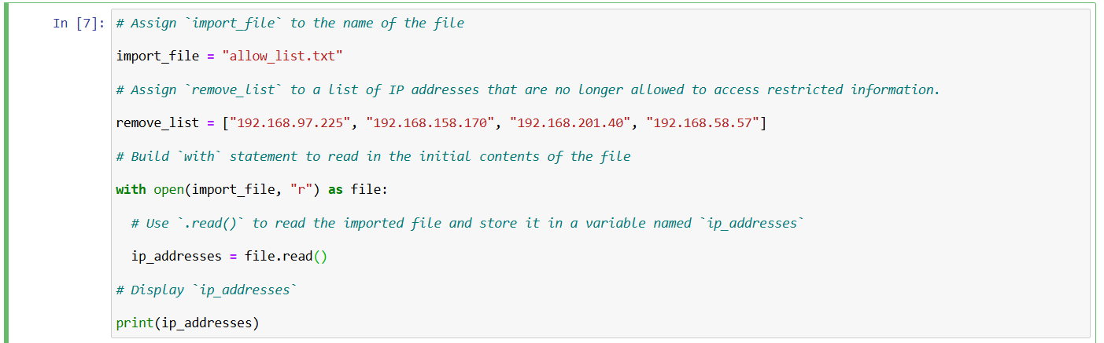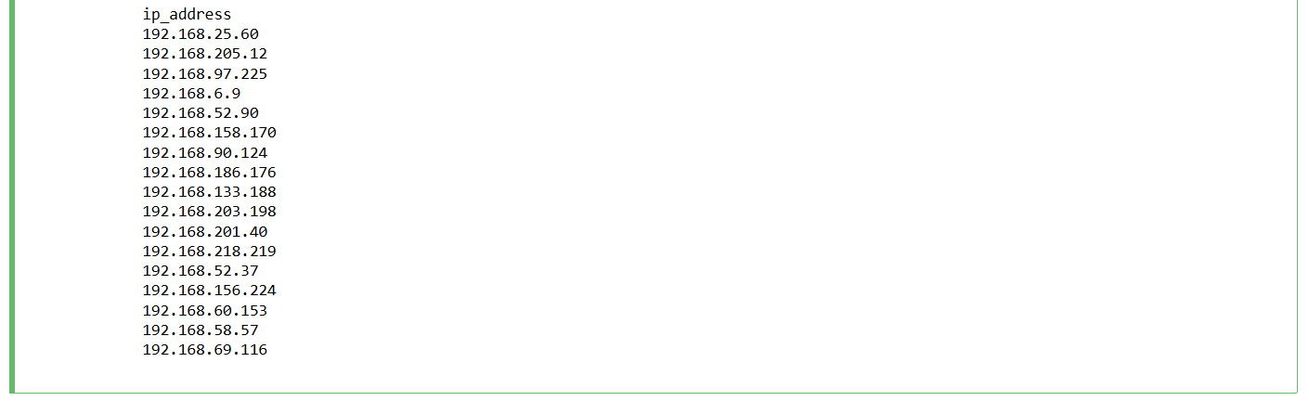

In order to read the file contents, I used the .read() method to convert it into the string.

This code reads the contents of the "allow_list.txt" file into a string format that allows me to later use the string to organize and extract data in my Python program.

## 

## 

## 

## Convert the string into a list

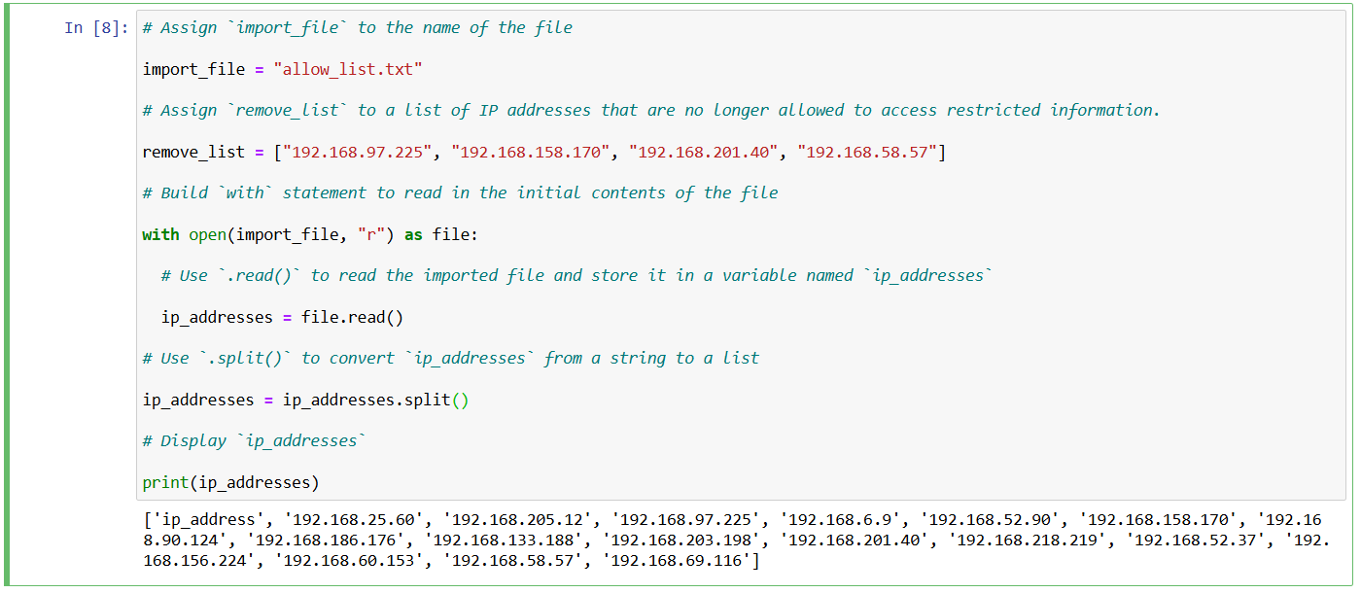

In order to remove individual IP addresses from the allow list, I needed it to be in list format. Therefore, I next used the .split() method to convert the ip_addresses string into a list:

In this algorithm, the .split() function takes the data stored in the variable ip_addresses, which is a string of IP addresses that are each separated by a whitespace, and it converts this string into a list of IP addresses. To store this list, I reassigned it back to the variable ip_addresses.

## 

## 

## 

## Iterate through the remove list

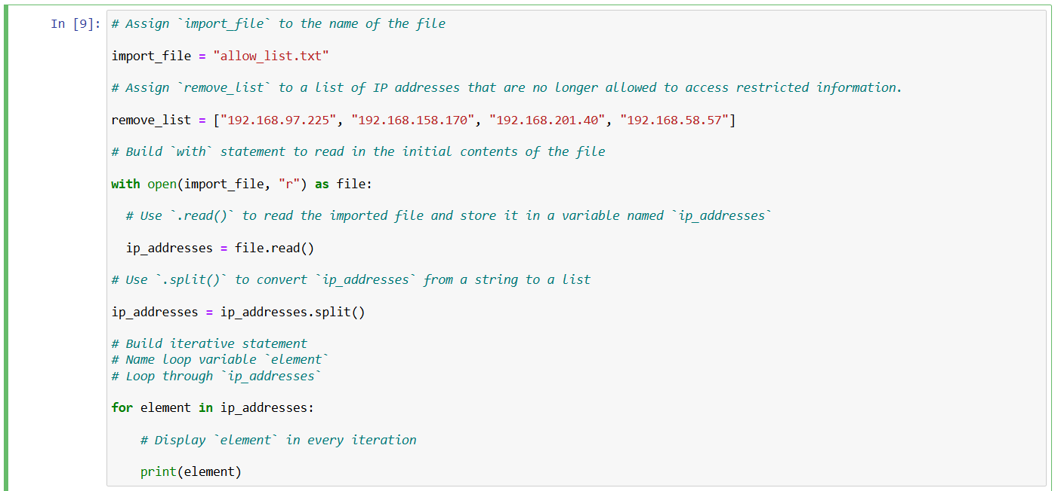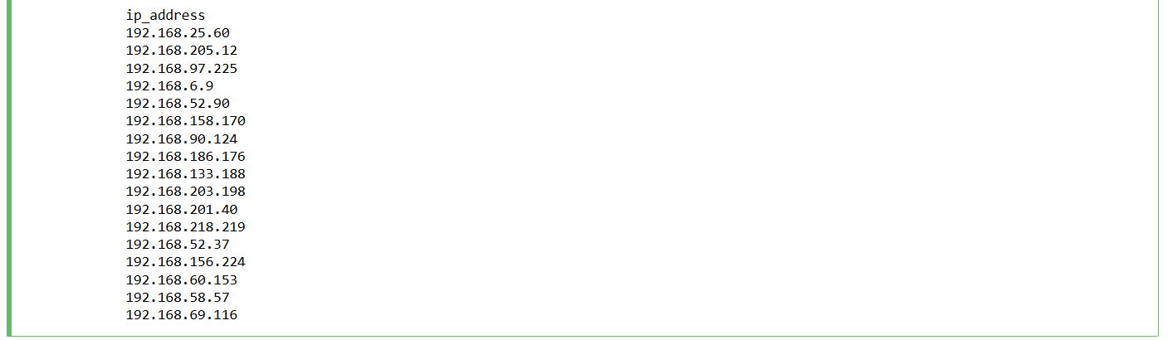

A key part of my algorithm involves iterating through the IP addresses that are elements in the remove_list. To do this, I incorporated a for loop.

The for loop in Python repeats code for a specified sequence. The overall purpose of the for loop in a Python algorithm like this is to apply specific code statements to all elements in a sequence.

## 

## Remove IP addresses that are on the remove list

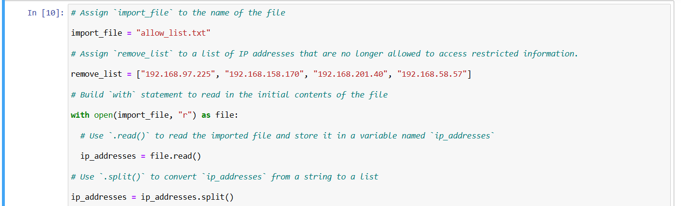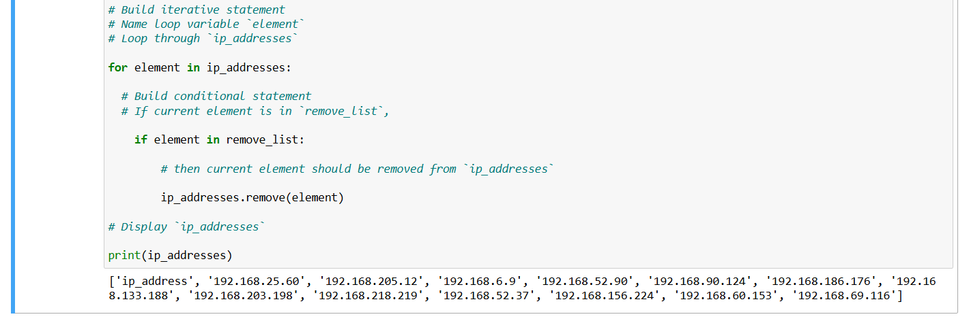

My algorithm requires removing any IP address from the allow list, ip_addresses, that is also contained in remove_list. Because there were not any duplicates in ip_addresses, I was able to use the above code to do that.

First, within my for loop, I created a conditional that evaluated whether or not the loop variable element was found in the ip_addresses list. I did this because applying .remove() to elements that were not found in ip_addresses would result in an error.

Then, within that conditional, I applied .remove() to ip_addresses. I passed in the loop variable element as the argument so that each IP address that was in the remove_list would be removed from ip_addresses.

## 

## 

## 

## 

## 

## 

## 

## 

## 

## 

## 

## Update the file with the revised list of IP addresses

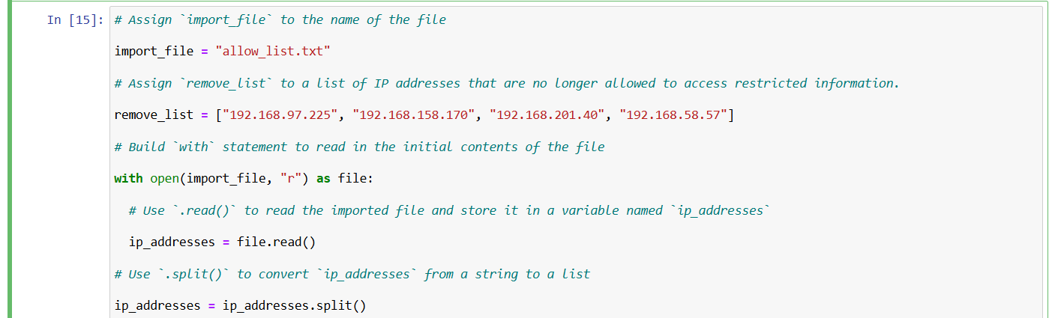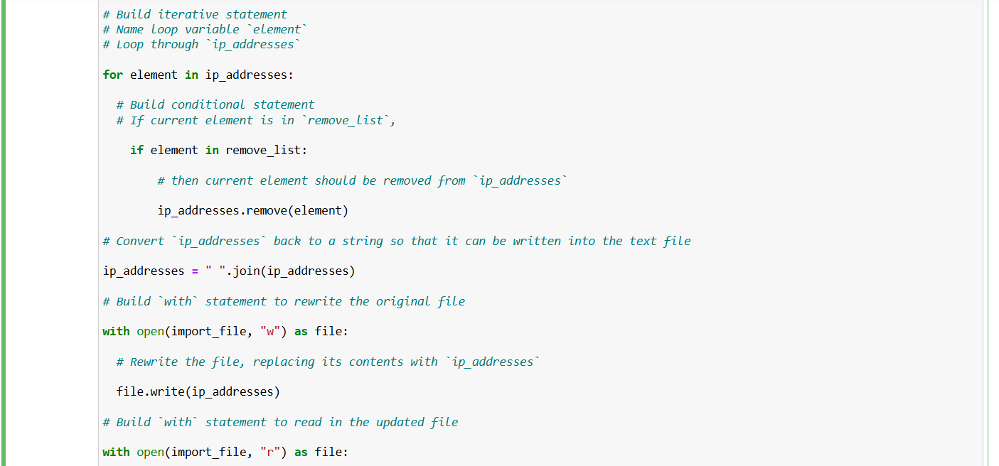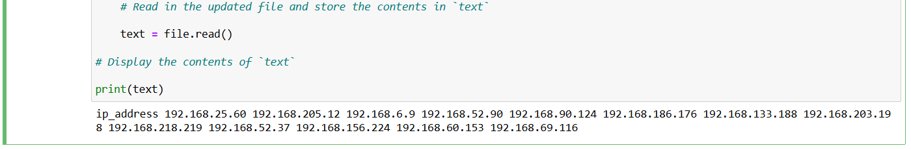

As a final step in my algorithm, I needed to update the allow list file with the revised list of IP addresses. To do so, I first needed to convert the list back into a string. I used the .join() method for this.

In this algorithm, I used the .join() method to create a string from the list ip_addresses so that I could pass it in as an argument to the .write() method when writing to the file "allow_list.txt".

Then, I used a with statement and the .write() method to update the file.

After that, I used another with statement and the .read( ) method to read the updated file and stored it in a variable named text to display it.

## Summary

I created an algorithm that removes IP addresses identified in a remove_list variable from the "allow_list.txt" file of approved IP addresses. This algorithm involved opening the file, converting it to a string to be read, and then converting this string to a list stored in the variable ip_addresses. I then iterated through the IP addresses in remove_list. With each iteration, I evaluated if the element was part of the ip_addresses list. If it was, I applied the .remove() method to it to remove the element from ip_addresses.. After this, I used the .join() method to convert the ip_addresses back into a string so that I could write over the contents of the "allow_list.txt" file with the revised list of IP addresses.